Underwater Vehicle Demo Requirements

**Goal: demonstrate the development workflow for an autonomous underwater vehicle**

This document outlines the high-level requirements for an underwater vehicle in order to illustrate how a similar team would map requirements into their Model-Based Design. The result will demonstrate how a digital thread can link requirements outlined in Microsoft Word all the way through to automatically generated code that would run on embedded hardware.

Autonomous Vehicle Development workflow

# Mission

The mission for this vehicle is to search for a “black box” acoustic beacon on seafloor, navigate toward it, take a photo of the area to bring to surface, and report back with data on its estimated location

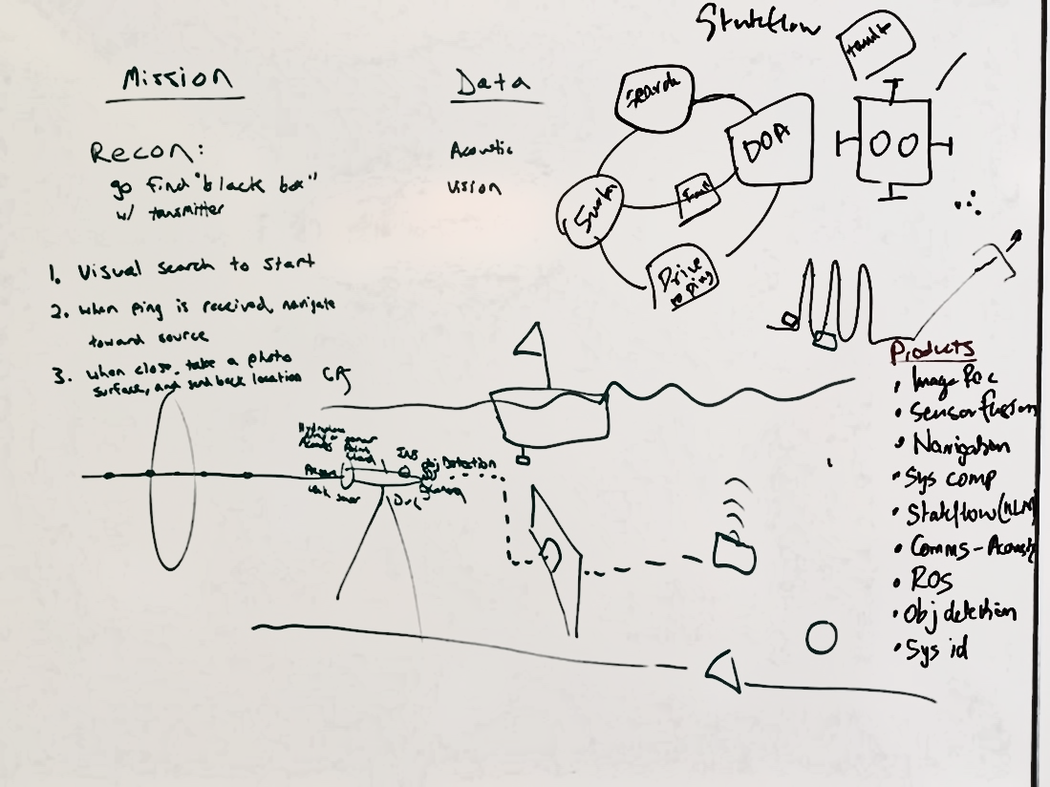

Figure : Whiteboard sketch of mission

# Functional Requirements

## Sensing

### The system shall be capable of processing a combination of on-board sensors to estimate the pose of the underwater platform using either active or passive means

### The system shall have on-board sensors capable of passively detecting an acoustic beacon signal

### The system shall have onboard sensors capable of detecting obstacles in the underwater vehicle’s direct path

### The system shall be capable of receiving commands from and communicating with an acoustic command system

## Perception

### The platform shall create, in real-time, an understanding of the underwater environment, including…

#### Bathymetry map of the sea floor

#### An understanding of the ocean currents

#### The existence and location of any solid obstacles in the direct path of the underwater vehicle

### If an underwater acoustic beacon is detected, the system shall be capable of estimating the position of the beacon relative to the underwater vehicle platform in local (e.g. North, East, Down) coordinates

### If an underwater acoustic beacon is detected, the system shall be capable of estimating the position of the beacon in global (e.g., earth-centered, earth-fixed) coordinates via acoustic signal

### The platform shall be capable of tracking the estimated position of the acoustic beacon over time

### The system shall determine whether the beacon is visually apparent if imagery is available

## Planning

### The system shall be capable of using its understanding of the underwater vehicle platform pose and the environment to create an initial search pattern that minimizes power consumption

### When an underwater beacon is detected, the system shall be capable of path planning to navigate toward the beacon, avoiding any perceived obstacles, while minimizing power consumption

### The system shall be able to determine whether there is enough power to navigate to the vicinity (10 meters) of the beacon and return to the surface with a predefined threshold of remaining battery

### The underwater vehicle shall be capable of planning a navigation path around any obstacles that may be in the area of operation

### The system shall be capable of planning a return-to-home path to a predefined user-requested location that minimizes power consumption

## Action

### The underwater vehicle shall autonomously navigate toward waypoints that are defined by the user or path planning algorithms

### The underwater vehicle shall run a search mode pattern until the expected battery level upon return to a designated home point is above a predefined threshold

### If a beacon is detected and there is enough power available, the system shall alert the operator and run the Beacon Intercept mission

### If a beacon is detected and there is not enough power available to intercept, the system shall alert the operator and wait 10 minutes for a command before executing return-to-home sequence.

### The underwater vehicle shall run a Beacon Intercept mode until the expected battery level upon return to a designated home point is above a predefined threshold

### Once within camera range, the vehicle shall capture images of the scene and save to on-board storage for visual confirmation upon surfacing

### Once there is visual confirmation, the underwater vehicle shall alert the operator of the estimated location of the beacon and execute return-to-home sequence.

## Mission Abort

### The system shall detect significant deviation from the planned path and if necessary, run return-to-home (RTH) or return-to-surface (RTS) mission abort sequence

### When initiated by a hardware fault or failure, the system shall be able to run a return-to-home (RTH) or return-to-surface (RTS) abort sequence. Faults and failures and the sequence they initiate are defined in Table 1.

Table 1: Fault and Failure table and sequences to initiate

|  |  |  |
| --- | --- | --- |
| **Fault/Failure Type** | **Fault/**  **Failure** | **Sequence to Initiate (return to surface or return to home)** |
| Leak | Failure | RTS |
| 10m deviation from path for 30 seconds | Fault | RTH |
| 50m deviation from path for 30 seconds | Failure | RTS |
| Max Depth Threshold Exceeded | Failure | RTS |
| Internal temperature HIGH threshold exceeded | Fault | RTH |
| Internal temperature CRITICAL threshold exceeded | Failure | RTS |
| Low battery threshold exceeded | Fault | RTH |
| Critical battery threshold exceeded | Failure | RTS |

### If requested by the operator, the system shall run a return-to-home (RTH) or return-to-surface (RTS) mission abort sequence

### The system shall communicate health and status (estimated location, battery, mode) to the user at a predefined interval when executing a mission abort sequence